**TASK – I**

**Tutorial:**

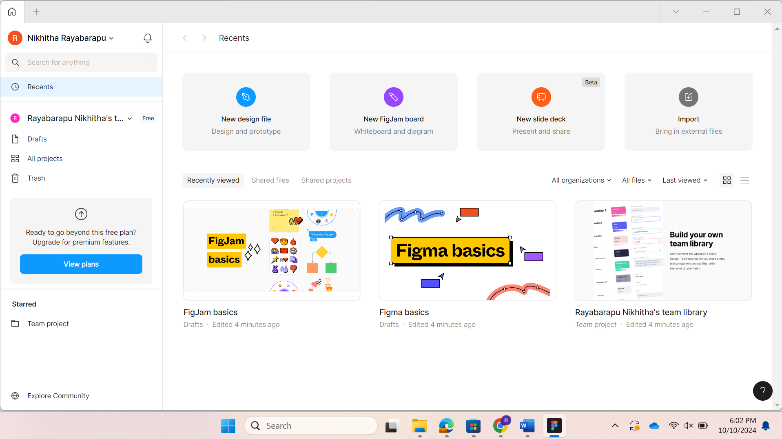

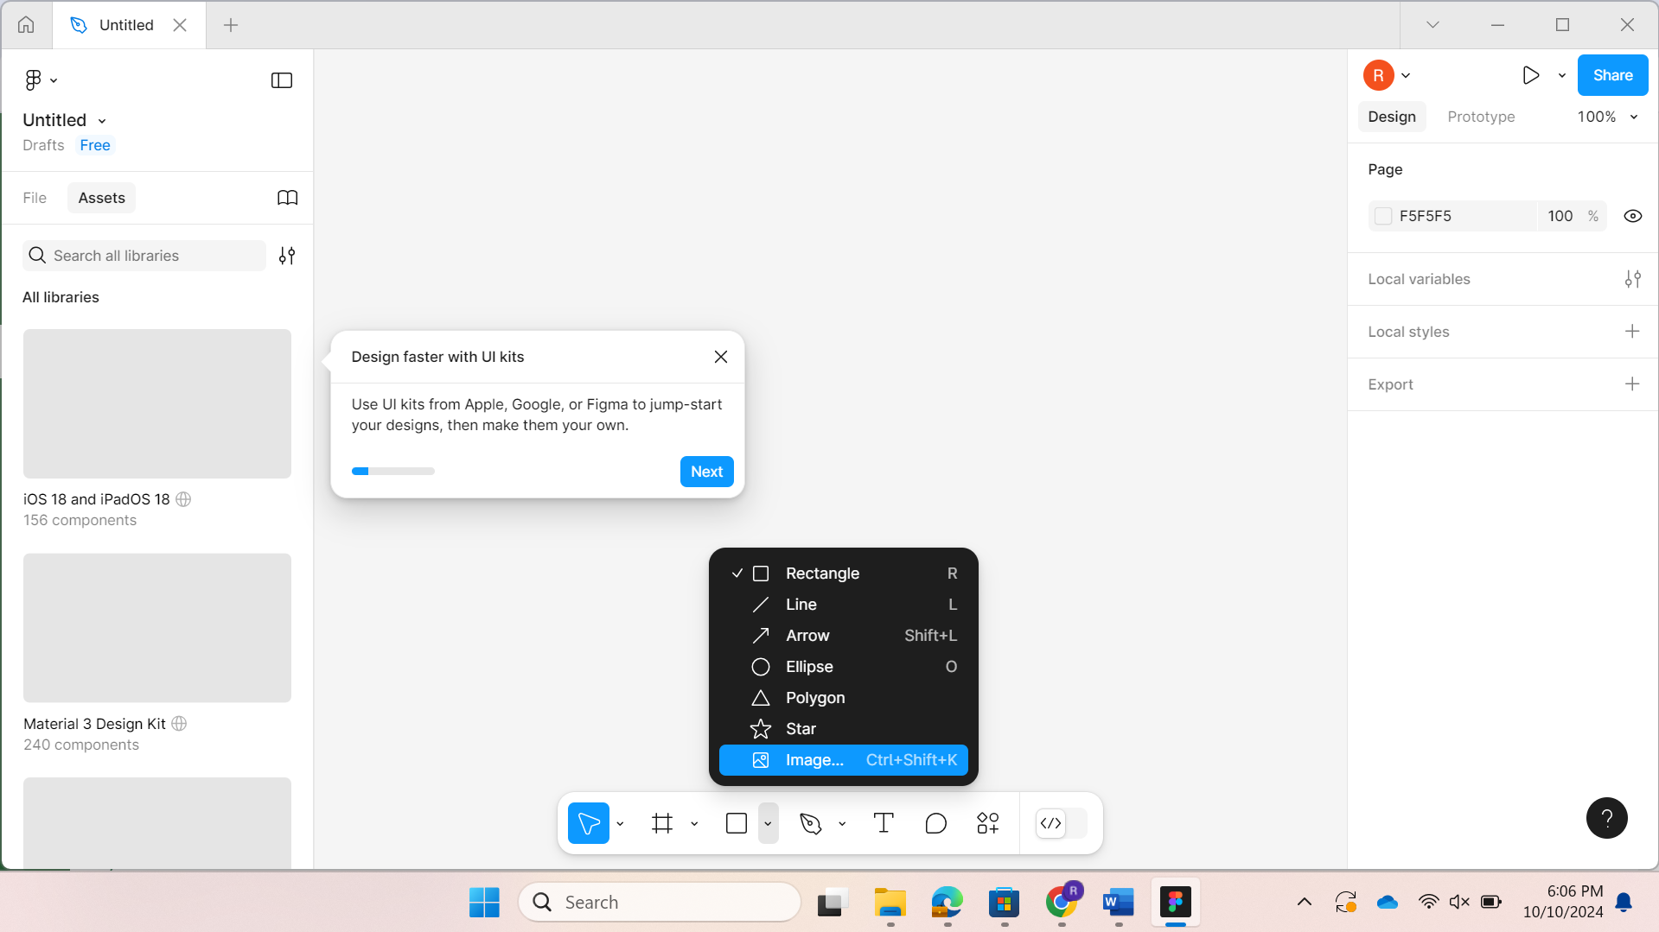

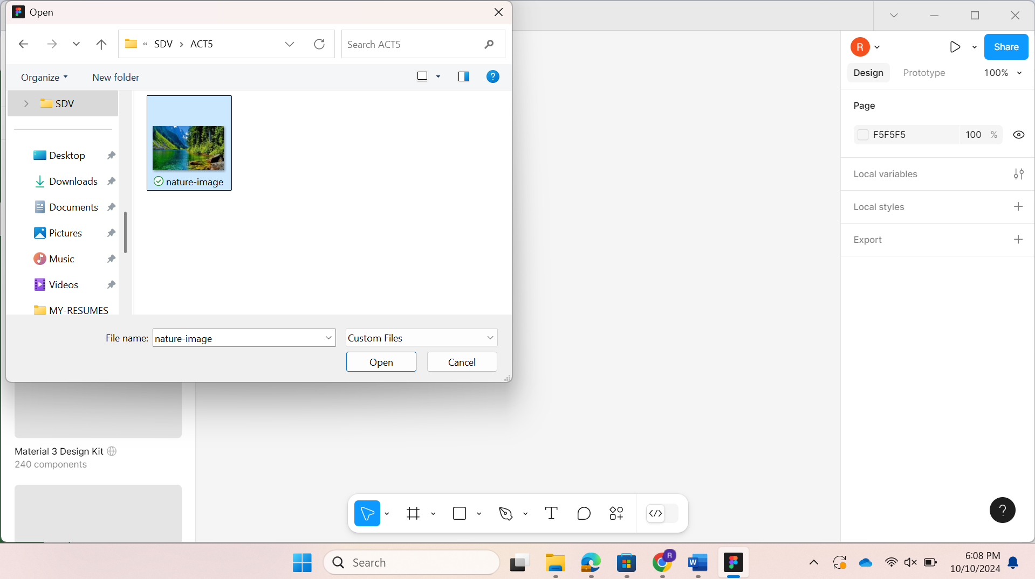

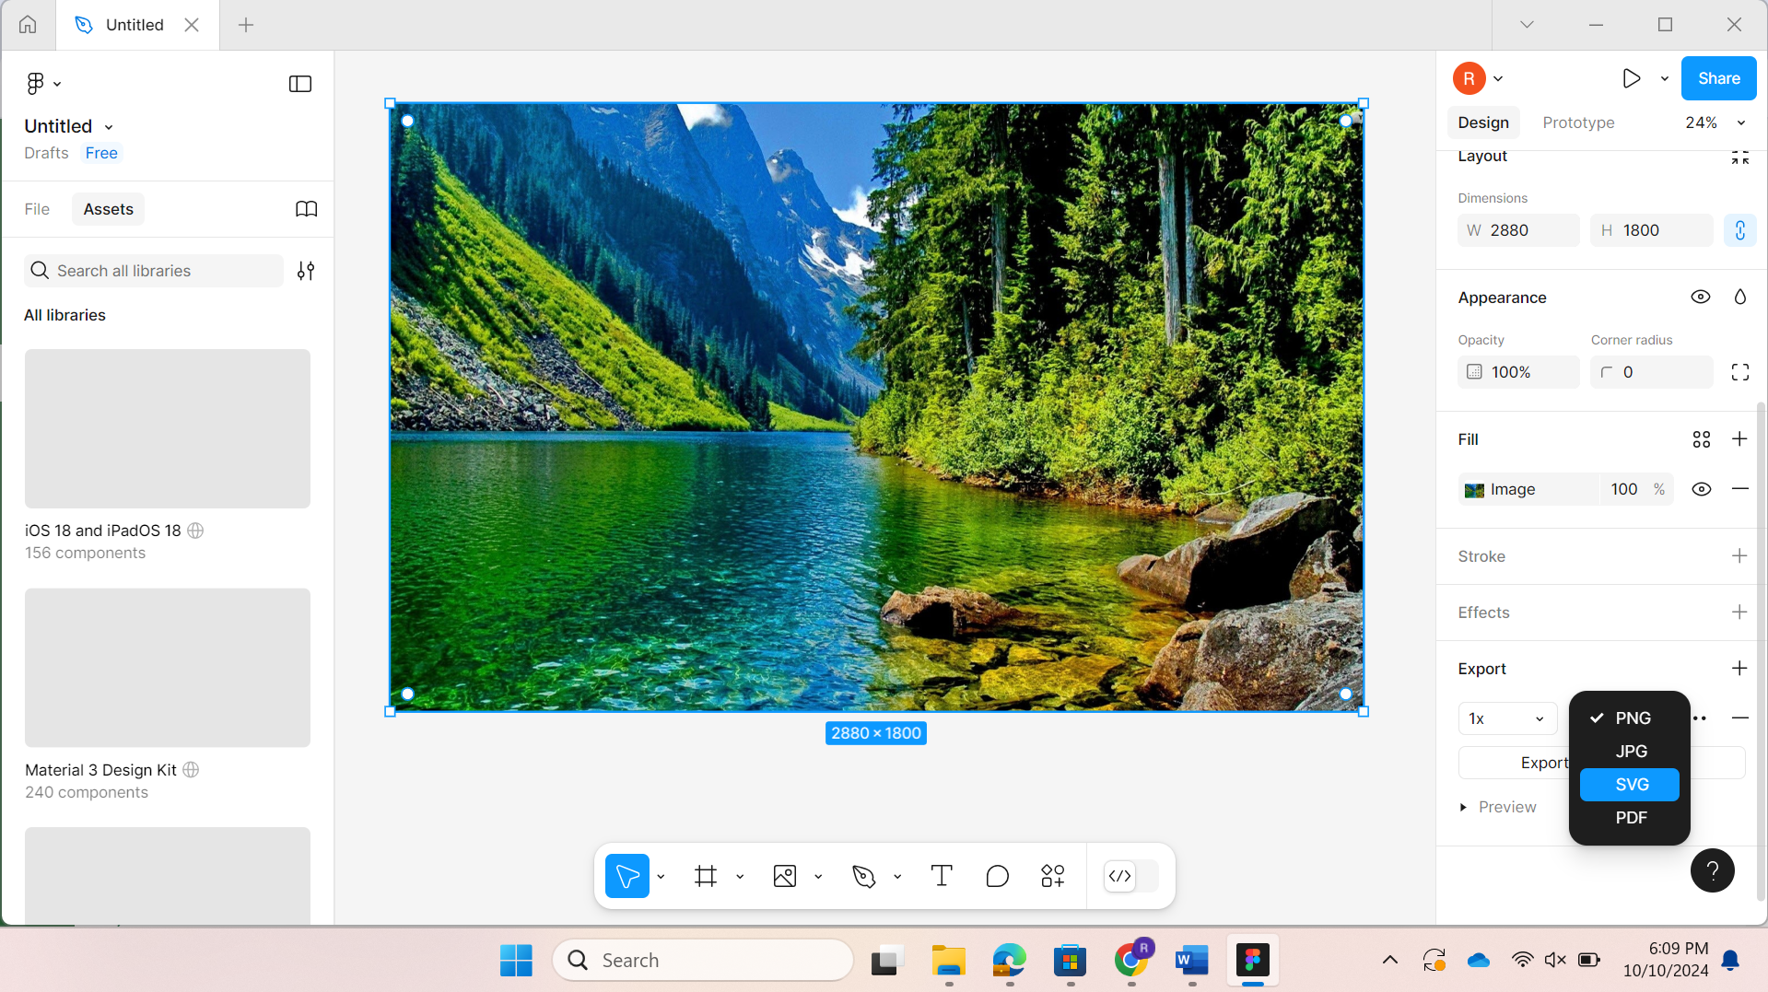

**Explanation:**

We are going to use Figma to create an SVG image. First, I downloaded the Nature-image.jpg that was provided and then uploaded it to Figma, and converted it to an SVG image.

Now, I’m going to create a webpage using Html and CSS as follows:

**tutorial.css**

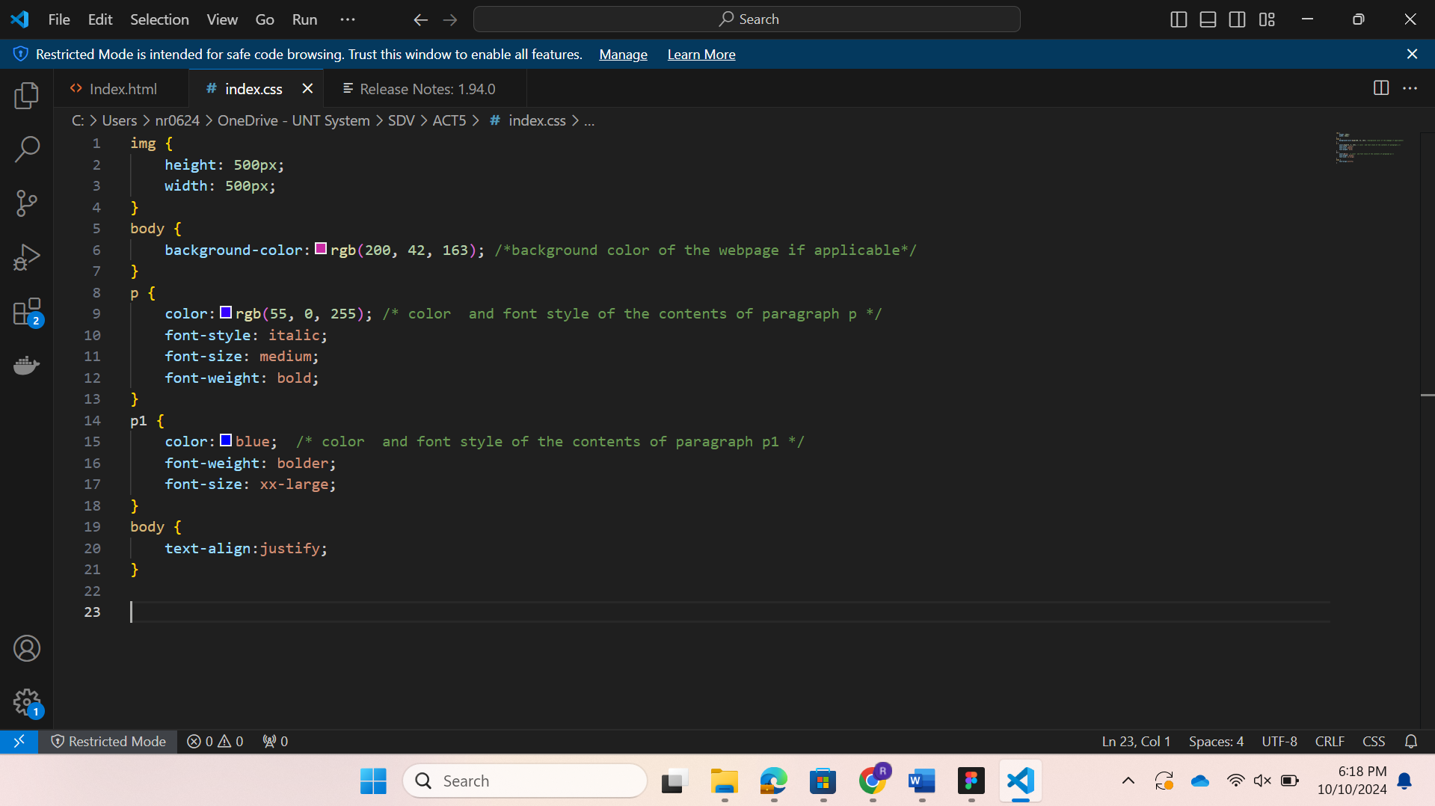

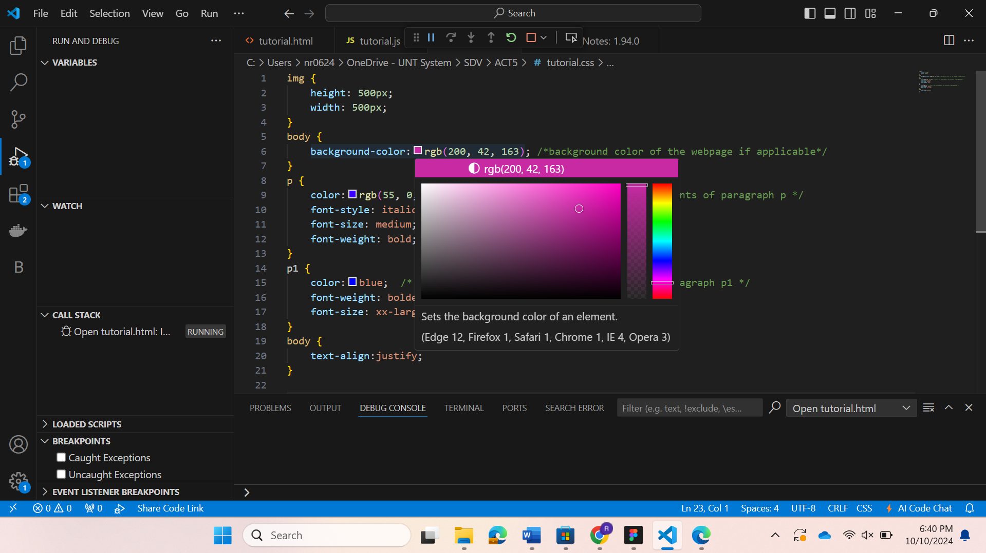

(we can change the background color as we want with the help of the palette)

**tutorial.html**

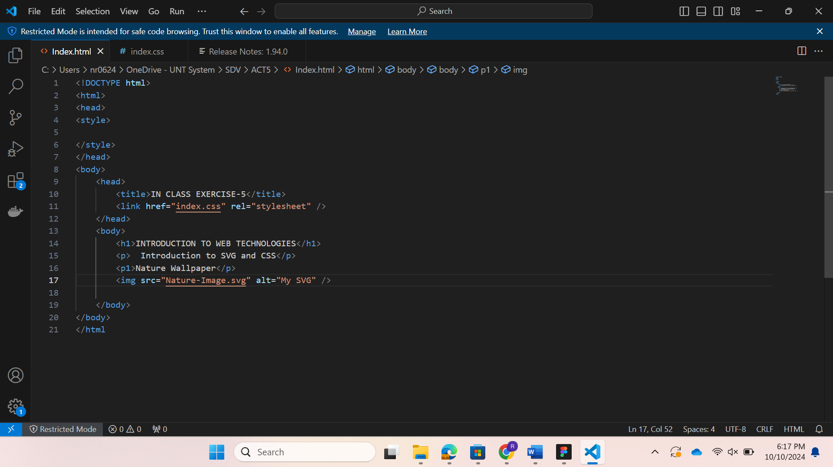

Run the code:

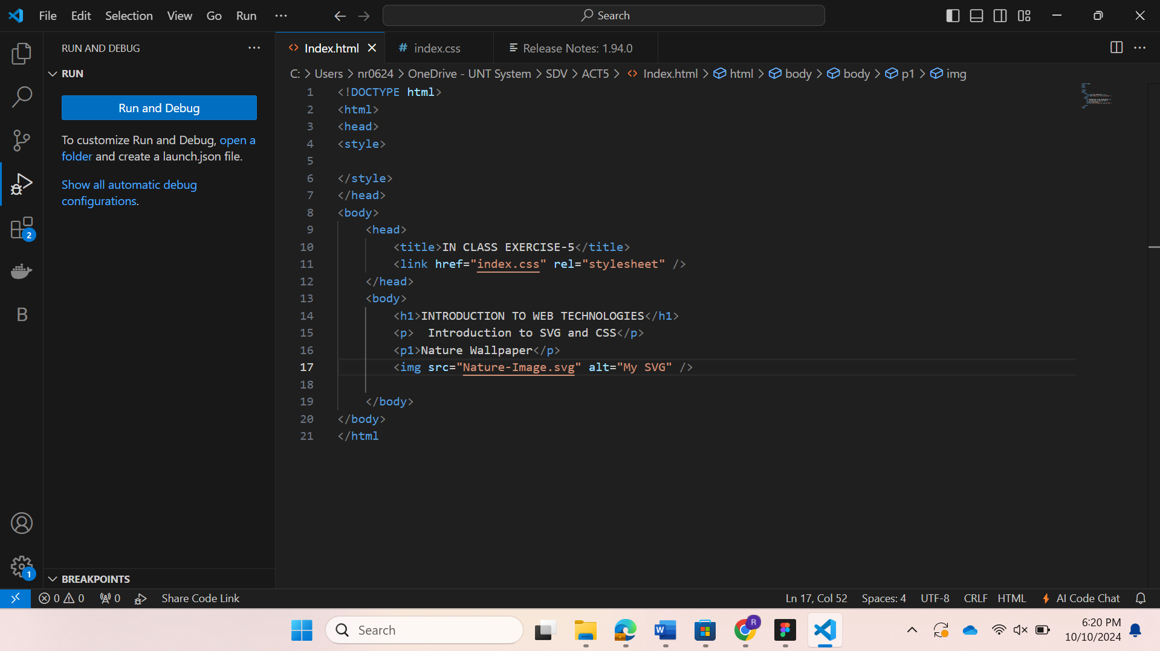

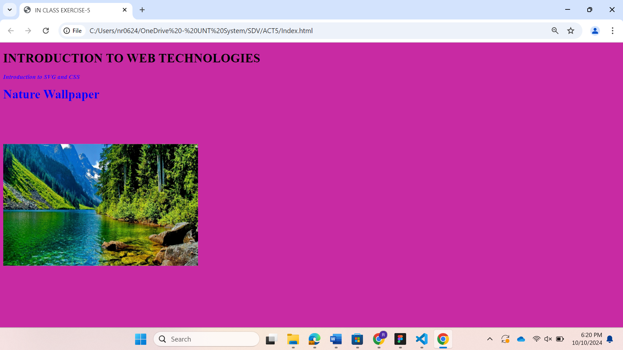

(This is the final web page formed)

**Questions:**  
1. 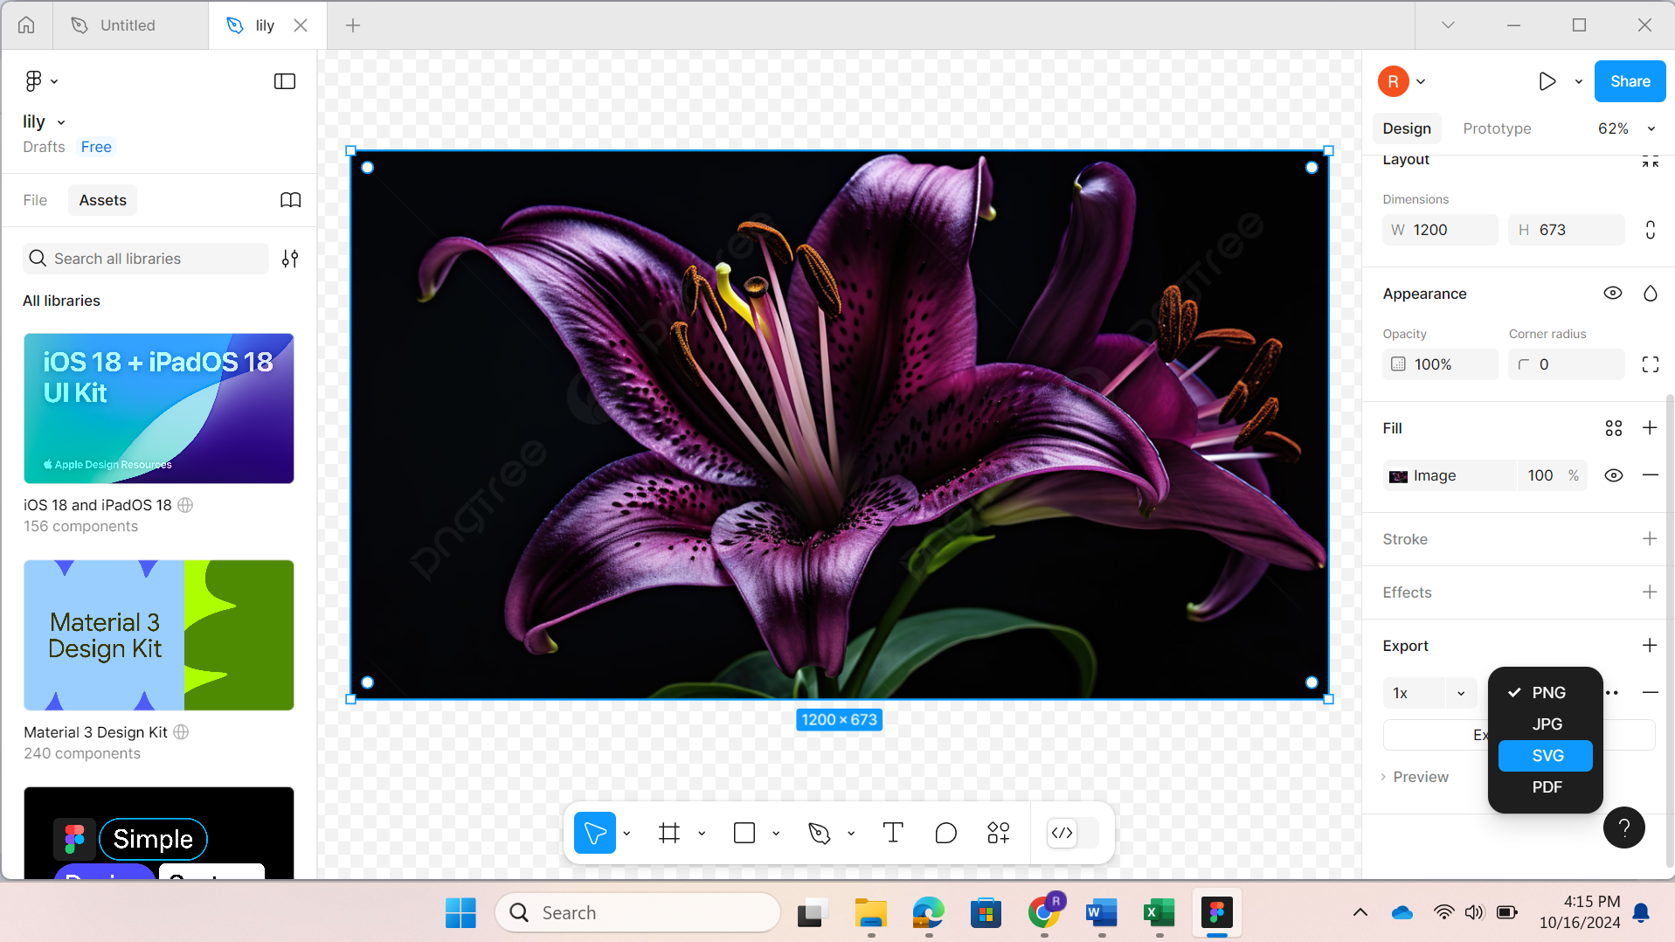

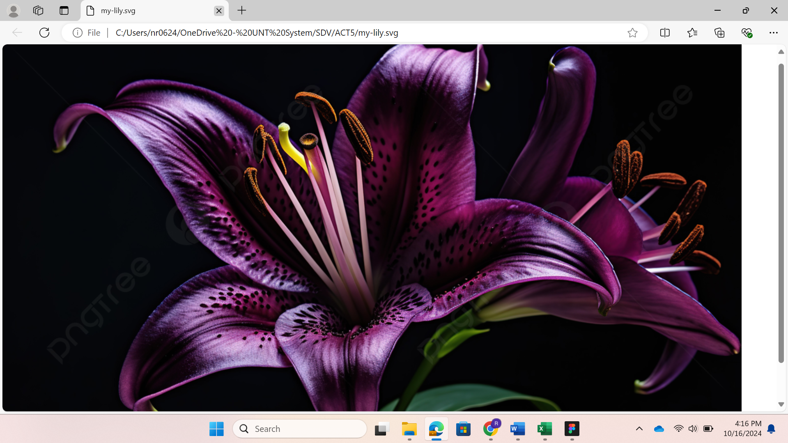

**question1.html**

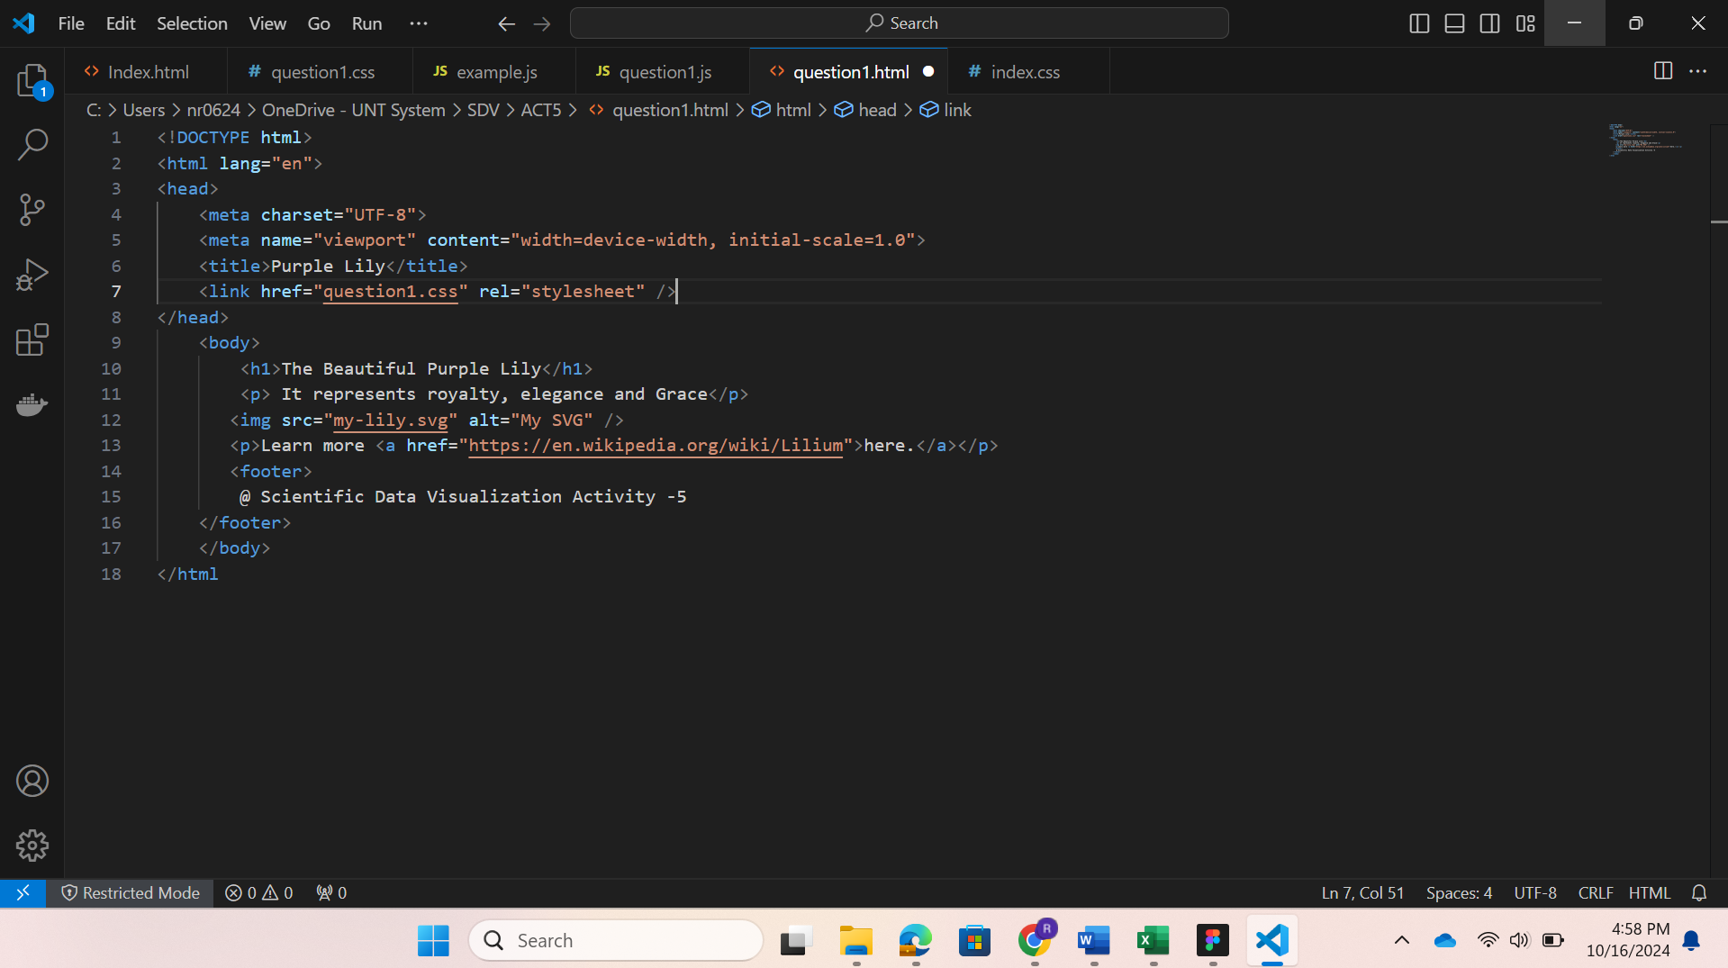

(I have used the tags: html, meta, title, head, body, link, h1, p, img, a, footer)

**question1.css**

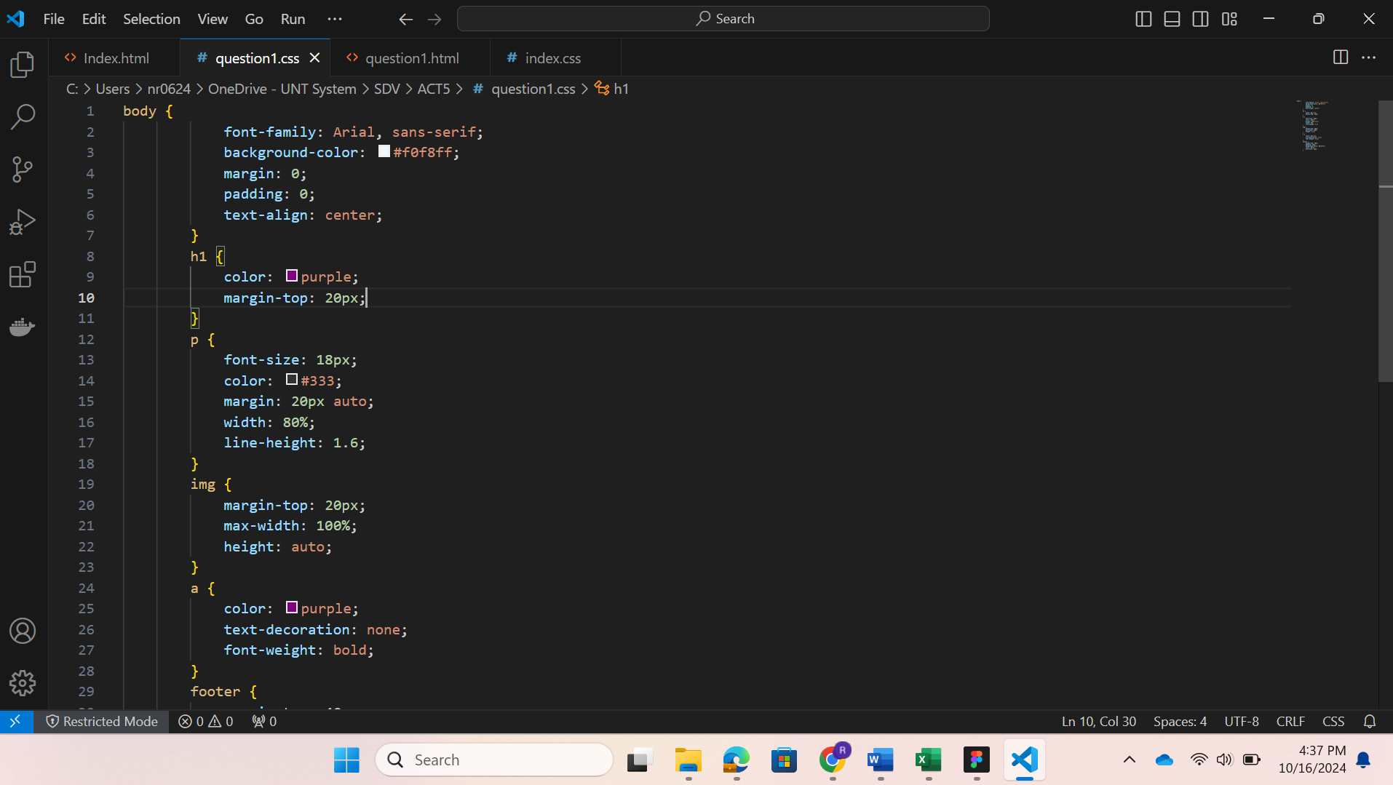

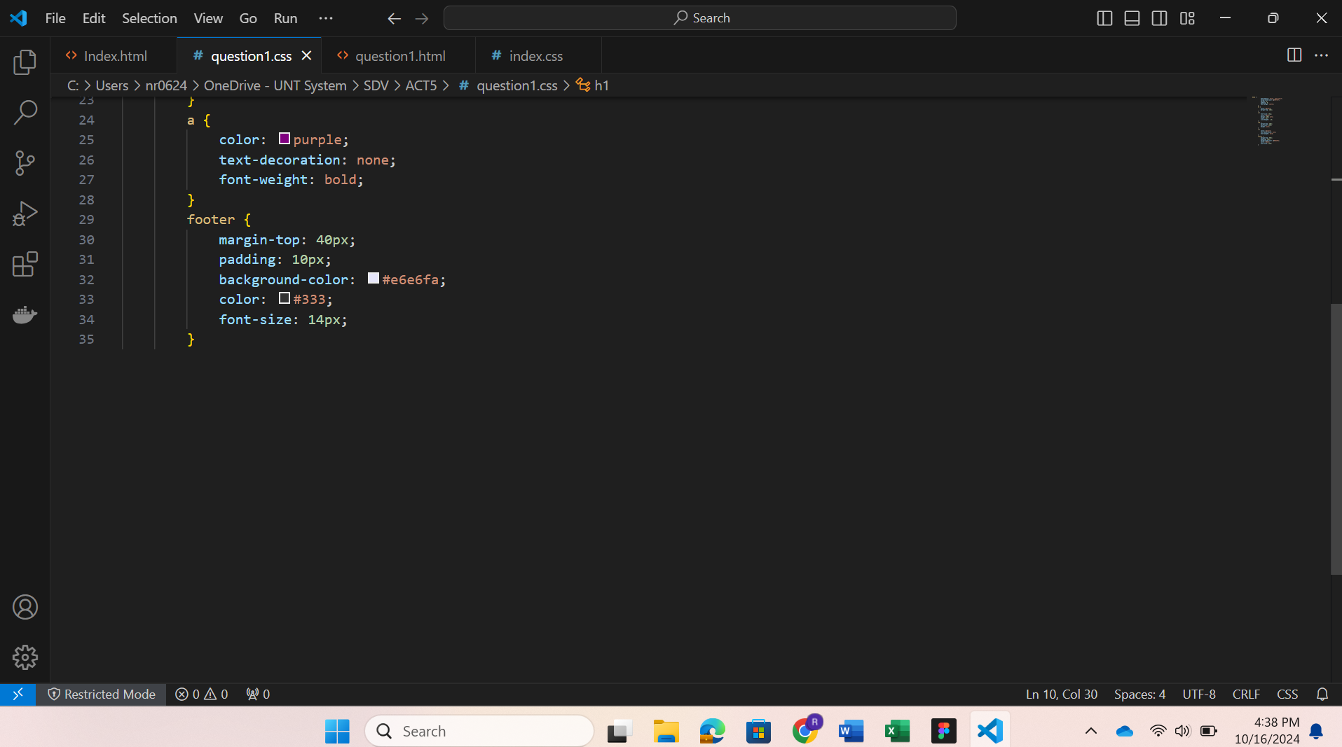

**Webpage:**

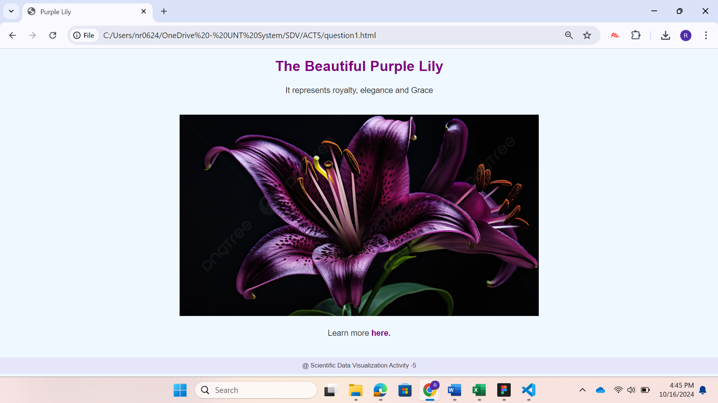

**Explanation:**

In this task, I have created a simple web page about purple lilies. I have converted my lily image to SVG format in Figma. And then, I embedded it in the HTML code and added some CSS code for a more visually appealing page. This task emphasizes embedding SVG into a webpage.

**TASK – 2**

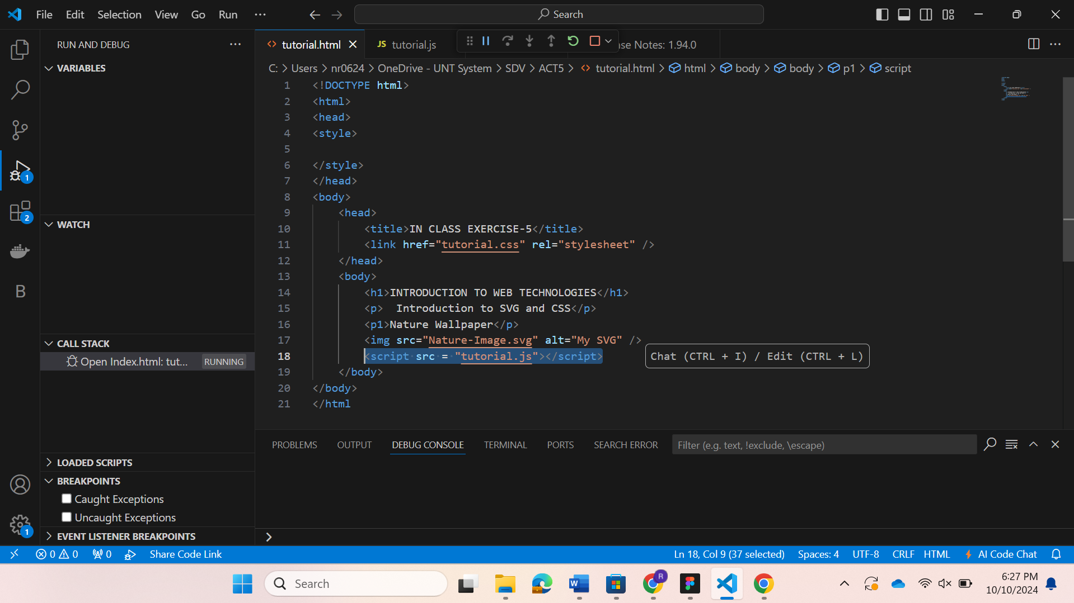

In my html code, I have added an extra line to get an alert before generating a webpage.

**tutorial.js**

Here I have specified my name and student ID: Nikhitha Rayabarapu – 11797058 as below:

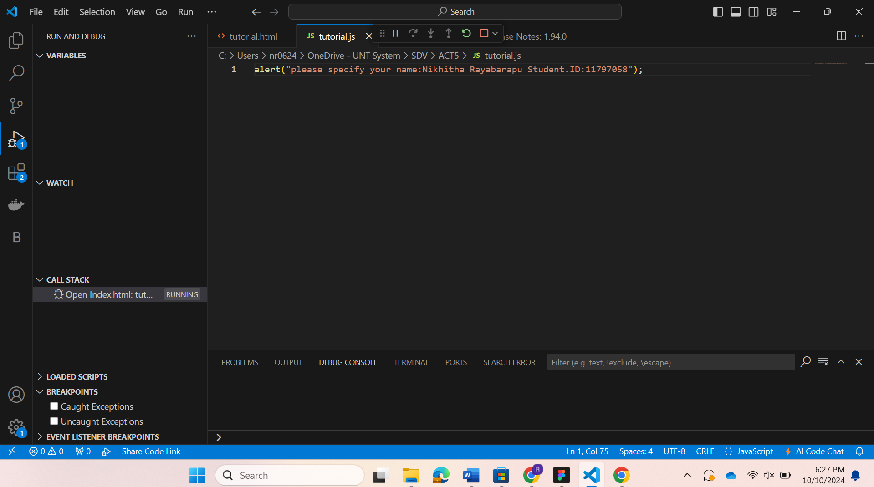

After running the code, the result is as follows:

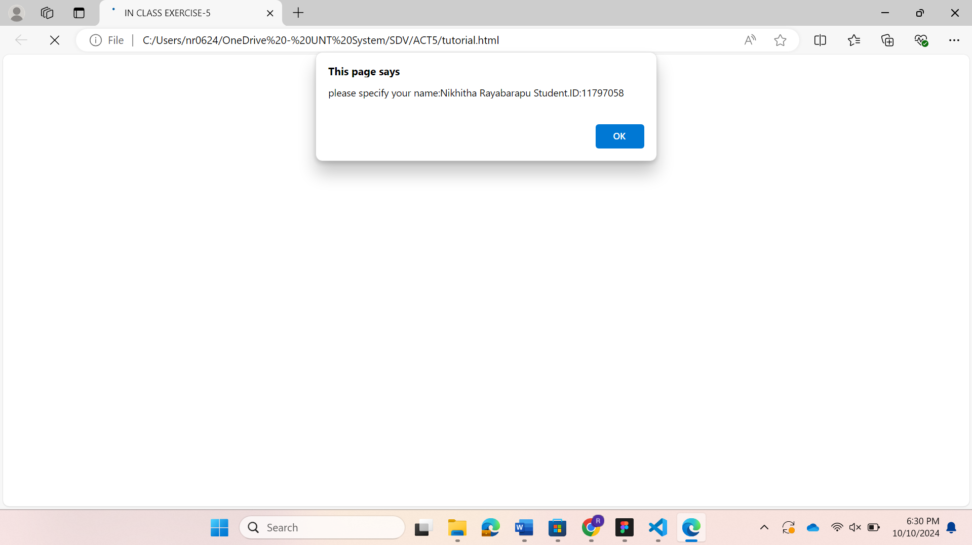

Here, the webpage is not displayed yet, but once I press the ‘OK’ button, it is displayed. This proves that out javascript code is working properly.

**Questions:**

**1&2.Java script code:**

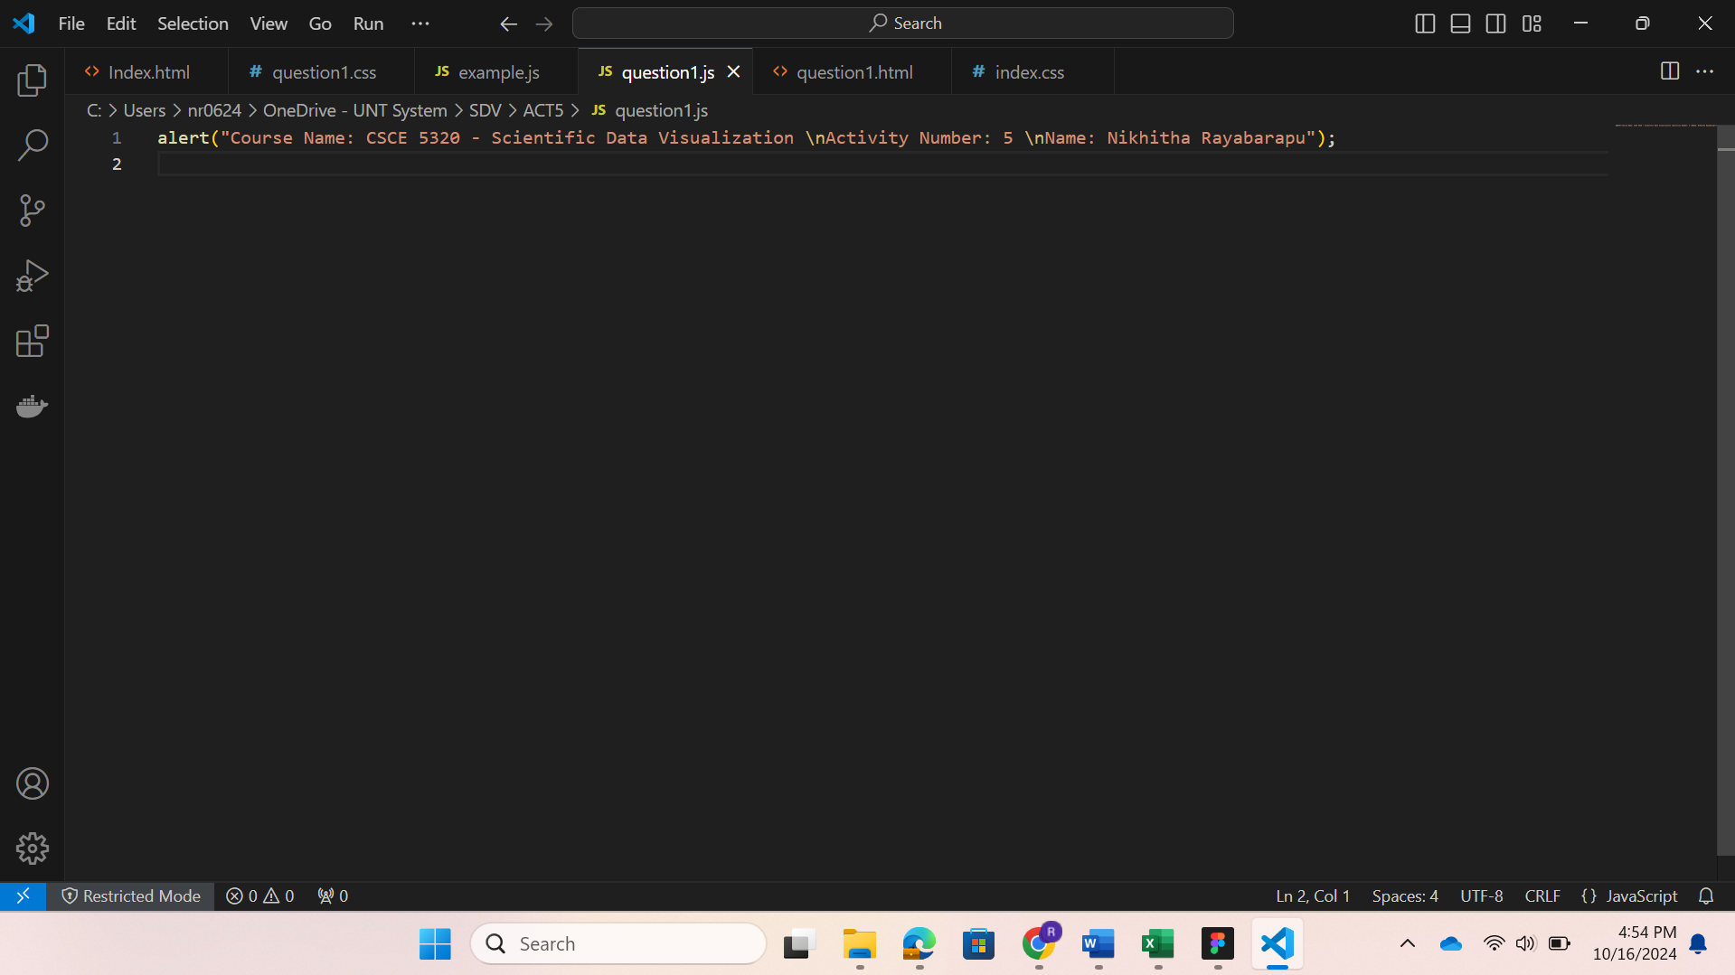

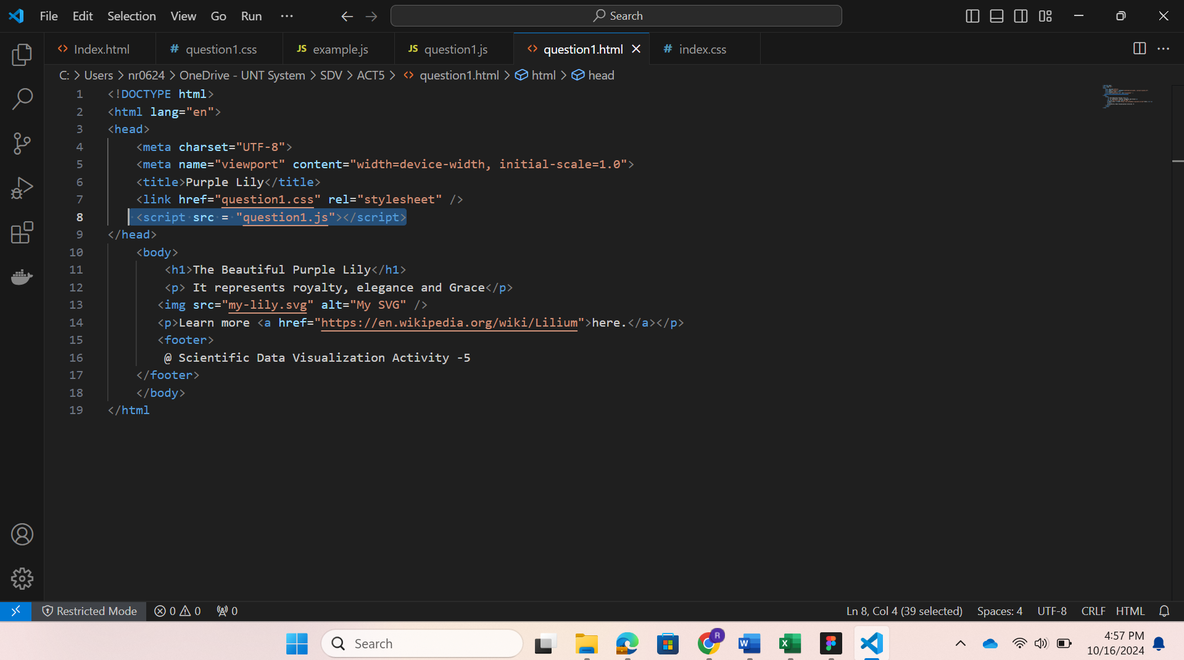

**3. Alert-page:**

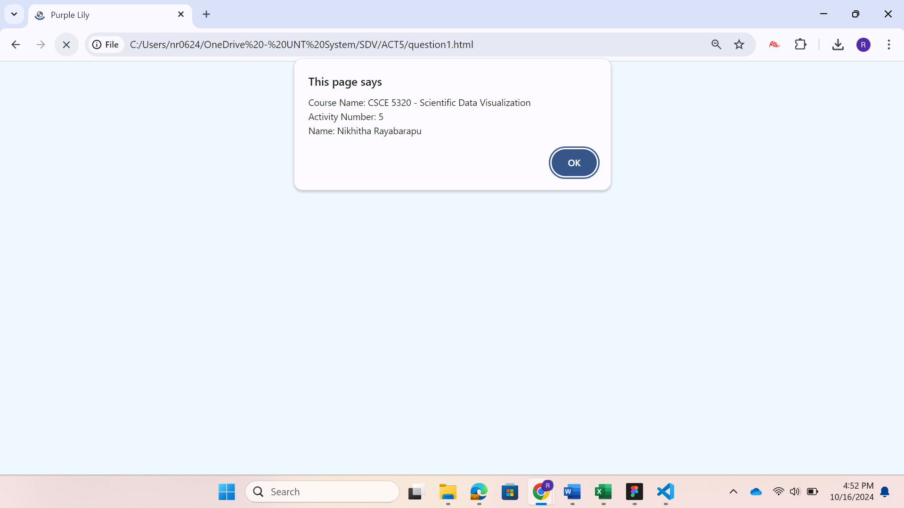

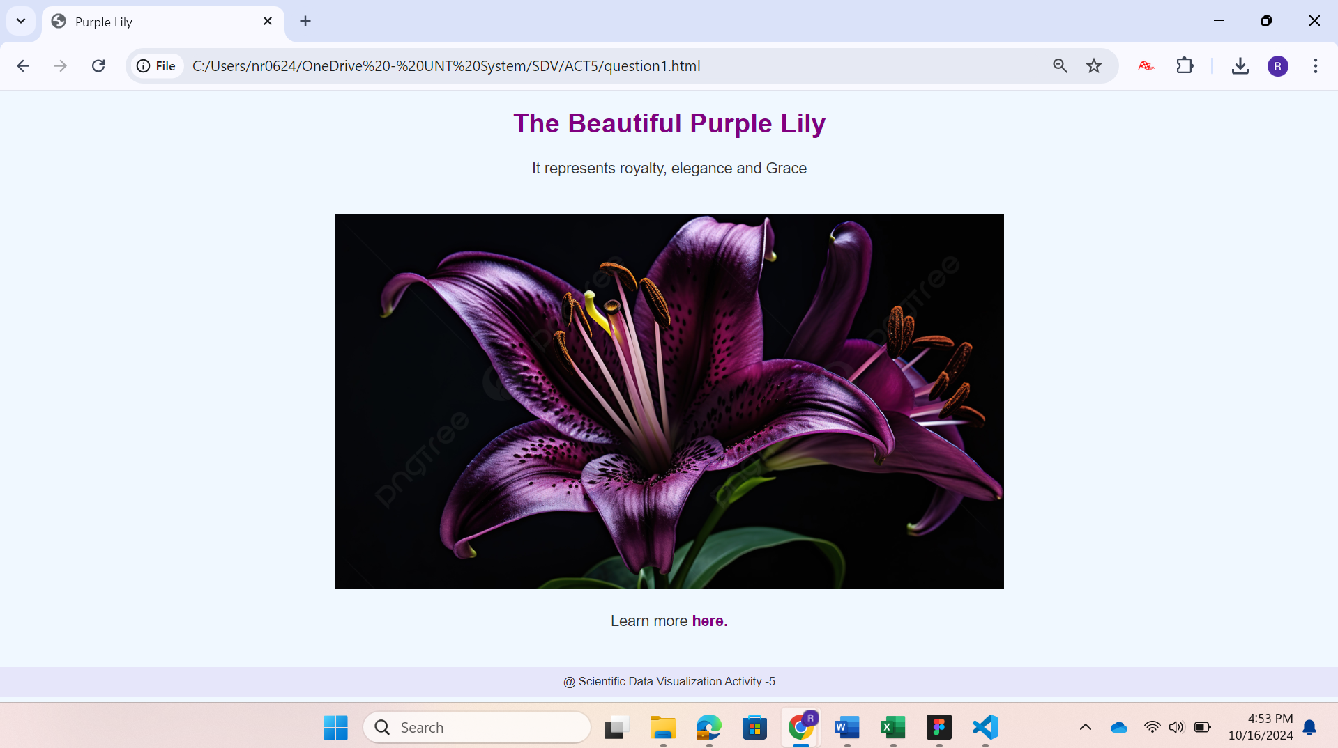

**4. Explanation:**

In this task, I have created a JavaScript file that creates an alert when we open the web page. In the alert, the Class name, activity number, and my name are displayed. Once the user presses OK, the web page is shown. This task explains how to create alerts using JavaScript and embed them in my webpage.

**TASK – 3**

I have opened VizHub and logged in and connected to my github account as shown below:

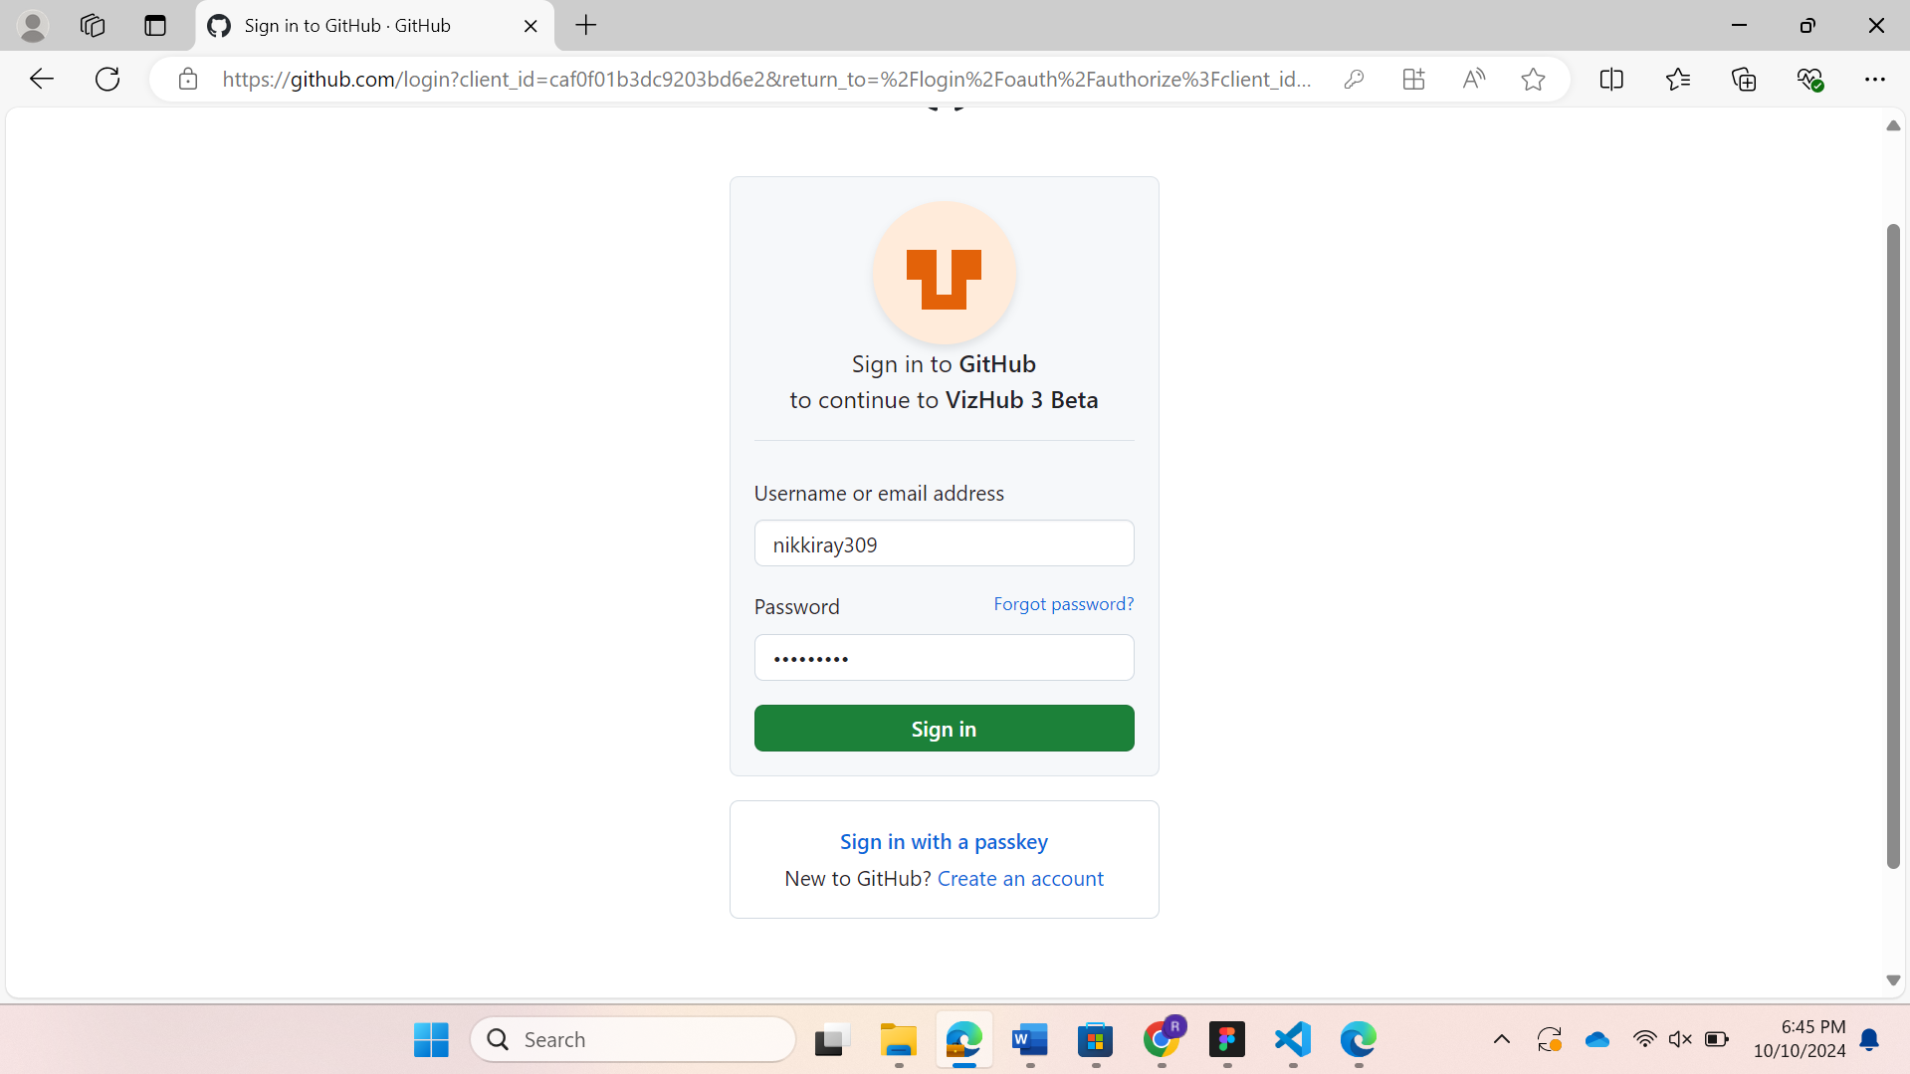

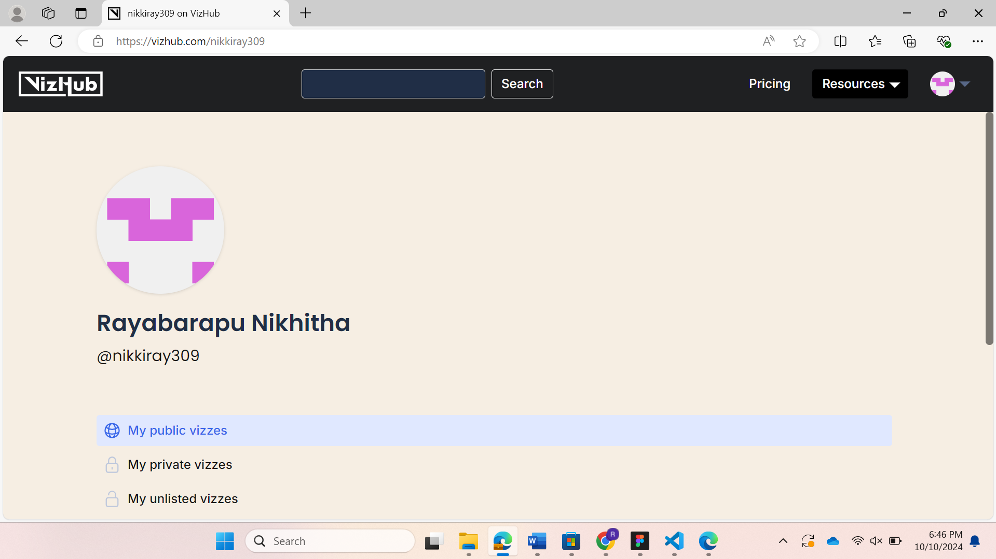

(Now my profile has been created)

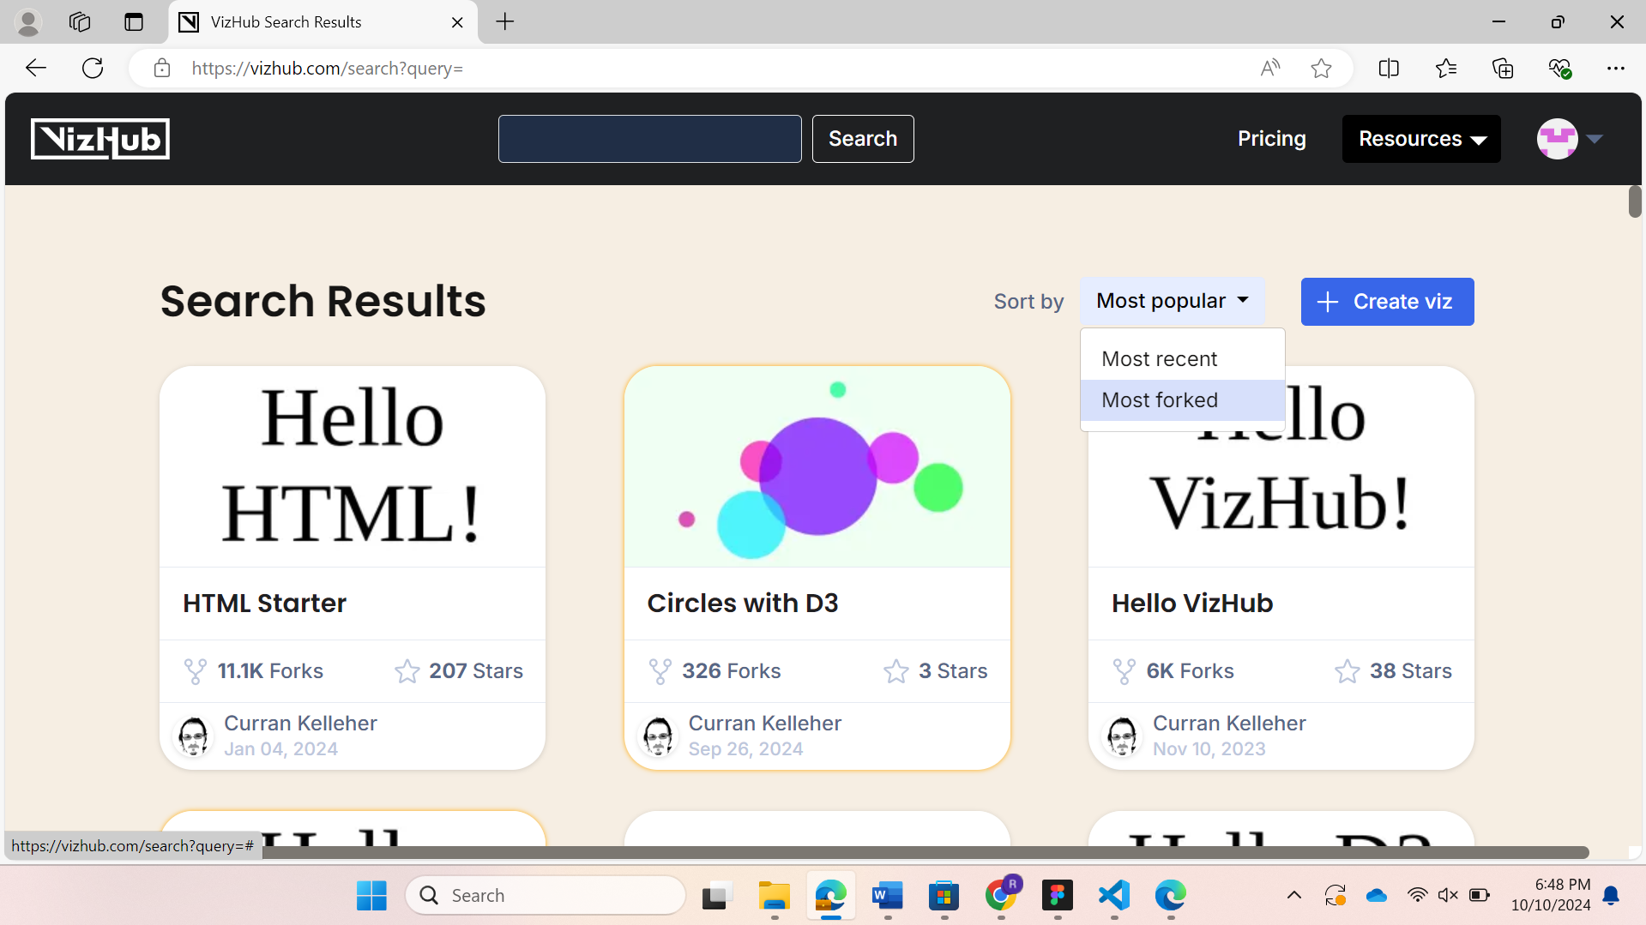

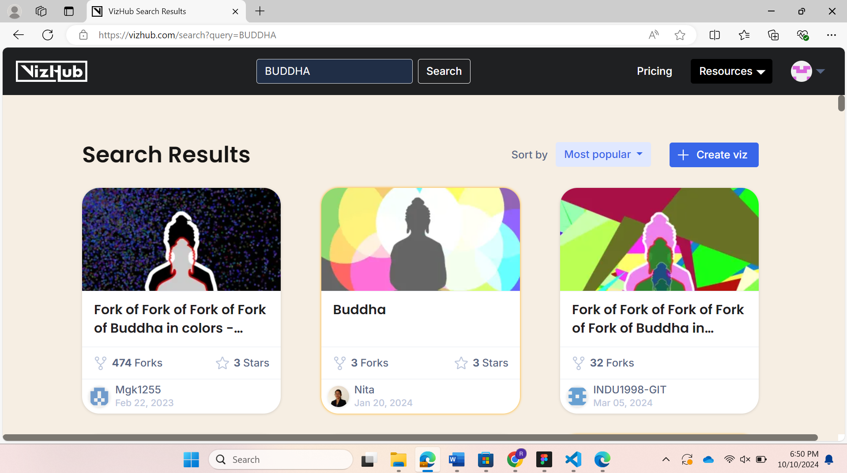

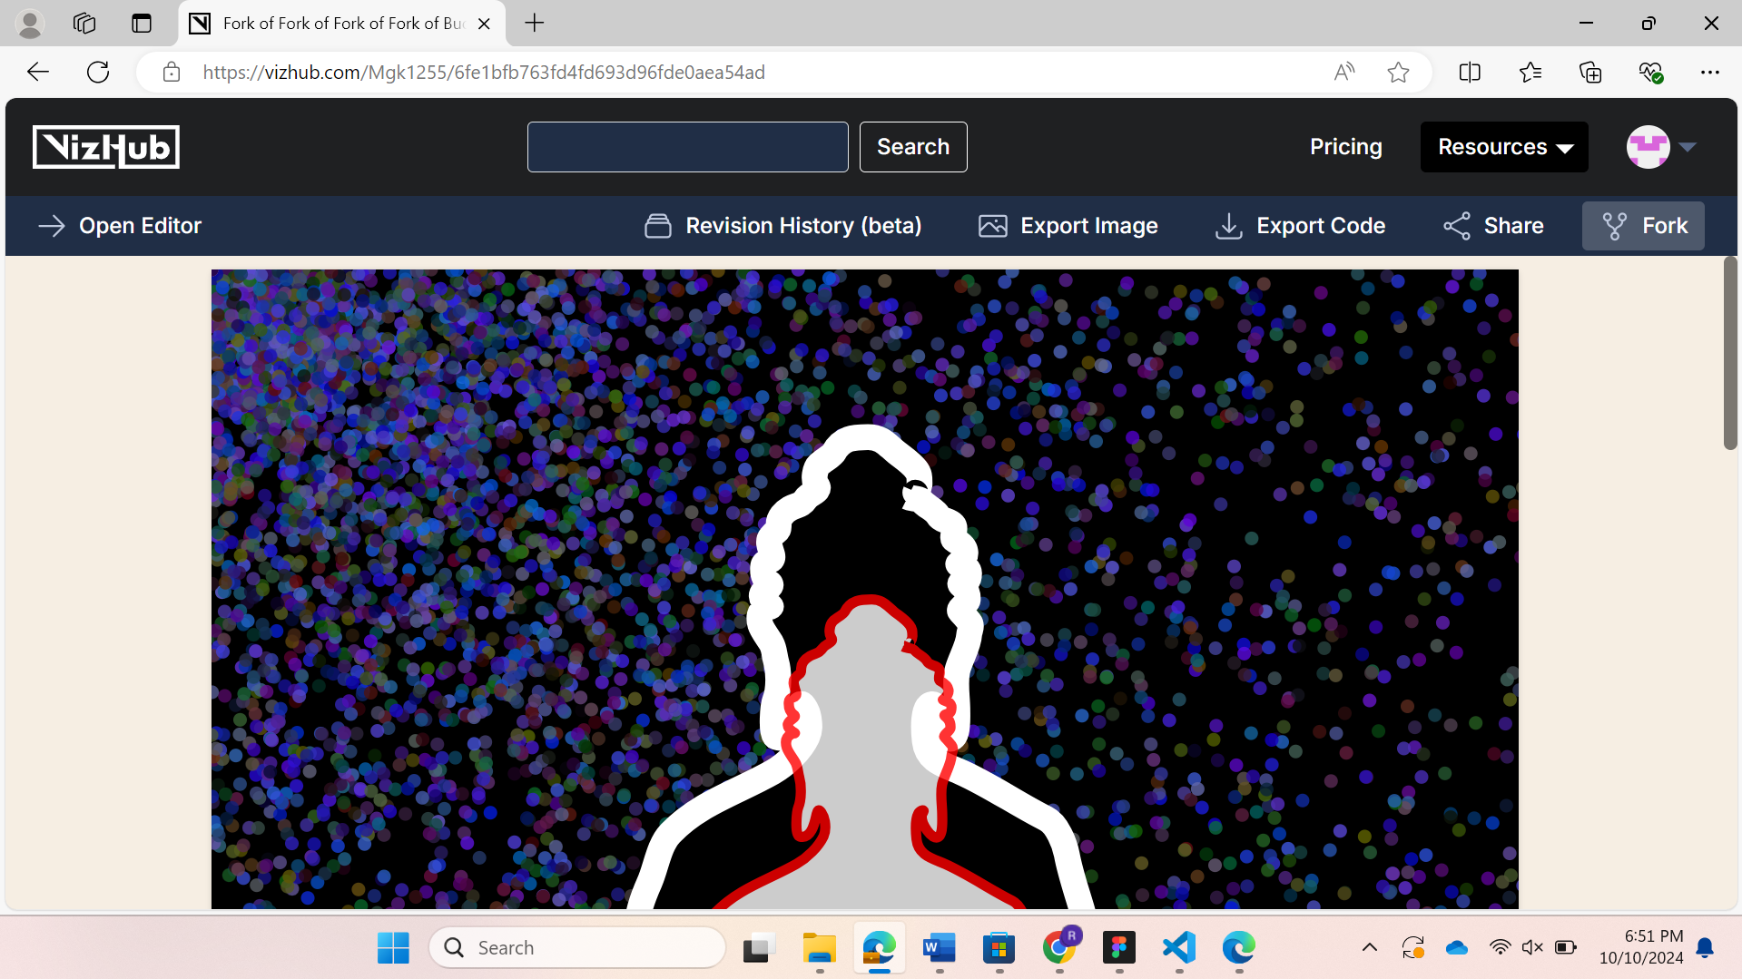

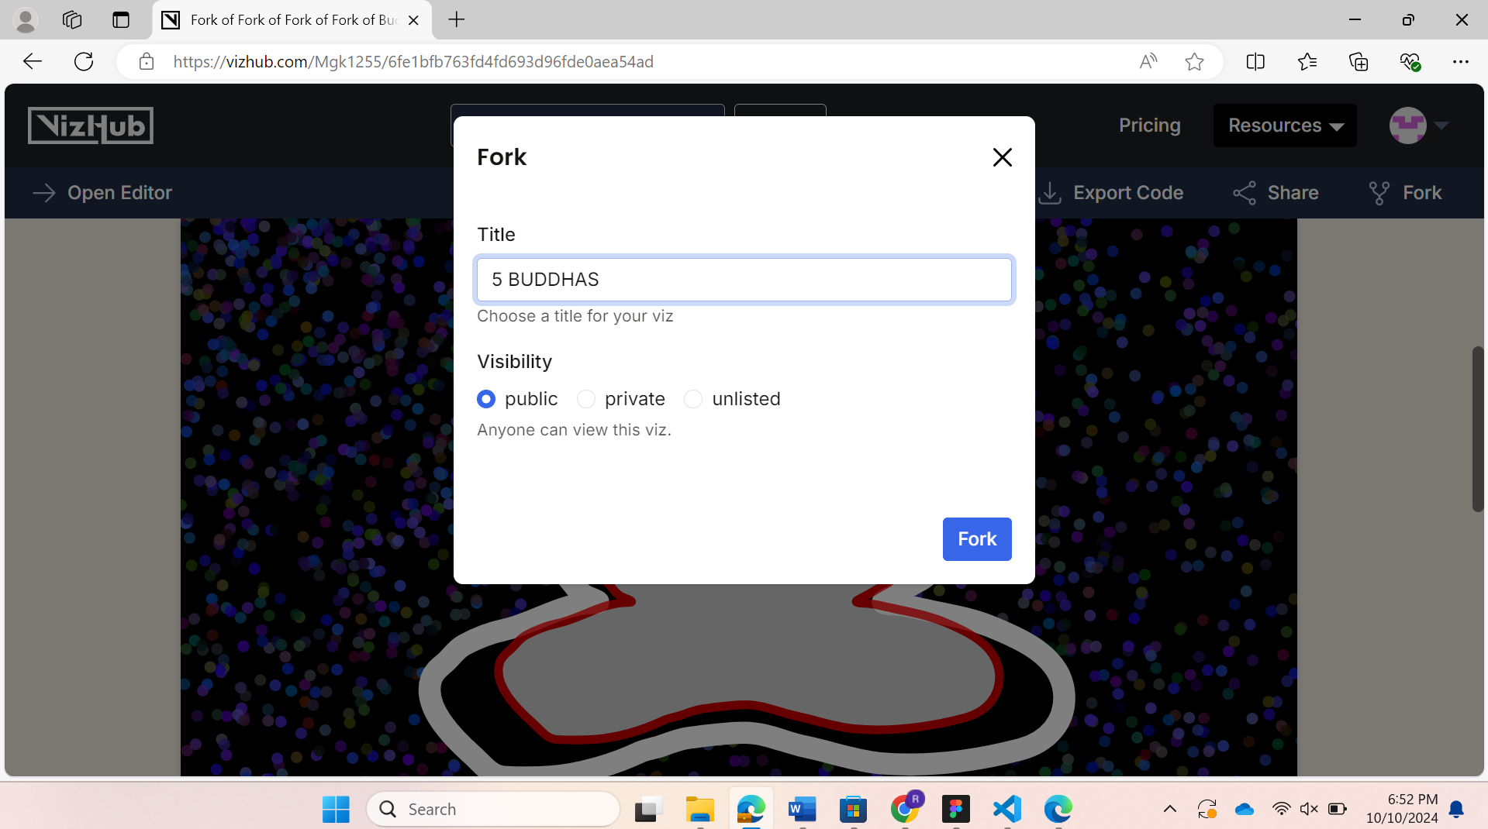

**Explanation:**

Here I have selected the Buddhas with 2 reflections as asked saved it as “5 BUDDHAS” & clicked on the `fork` button. I have done the below modification in my **index.js** code in the code editor and after running it I got 5 reflections Buddha background.

Before changes(2 Buddhas code)

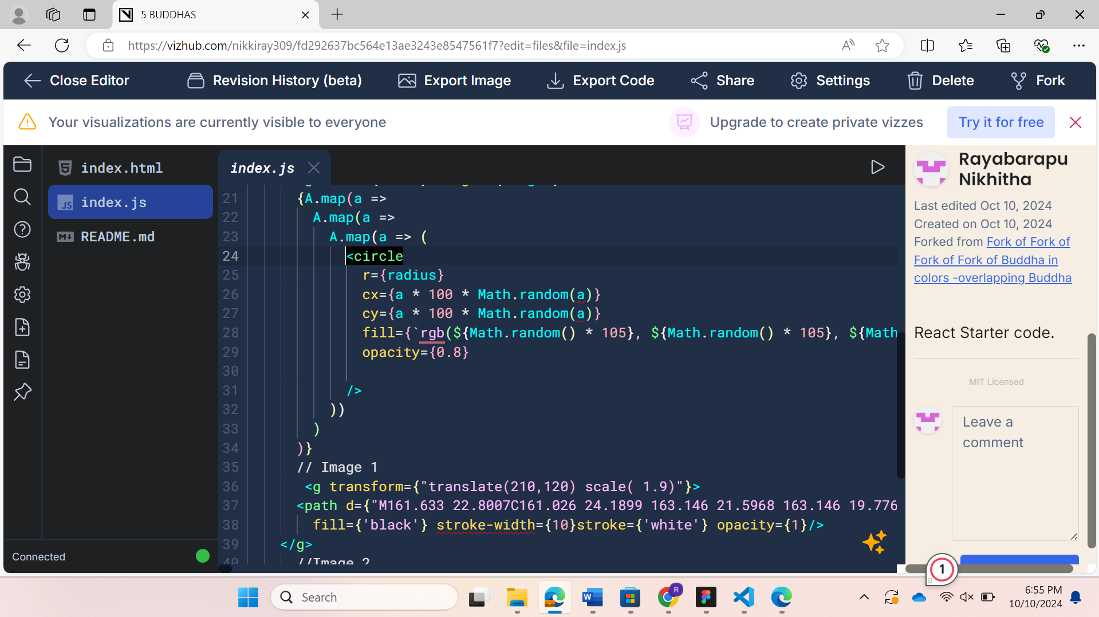

After changes (5 Buddhas):

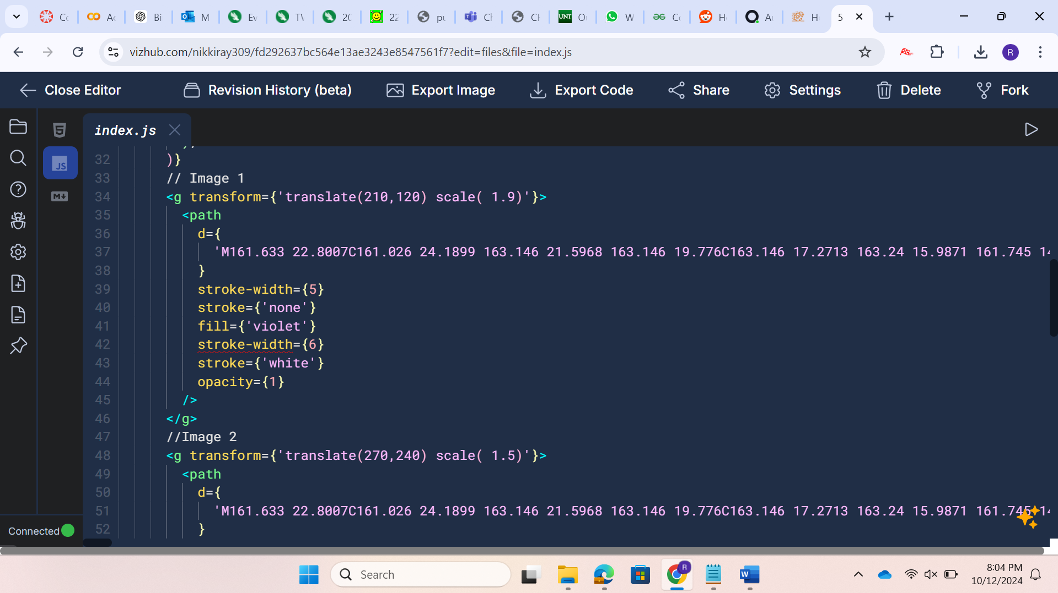

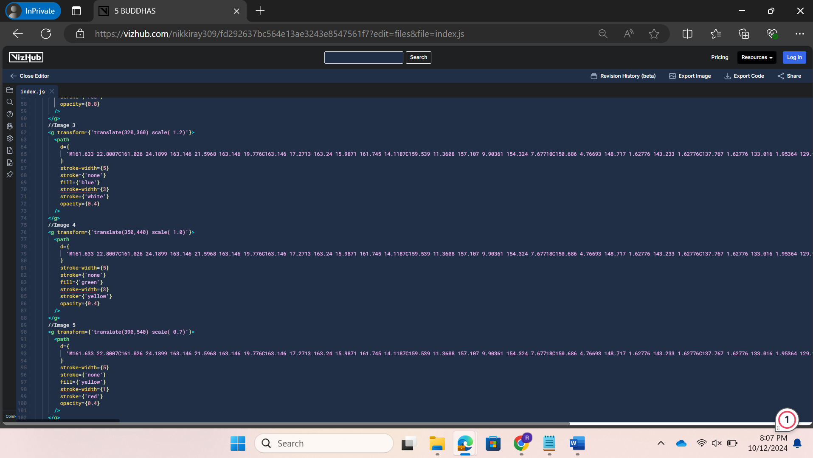

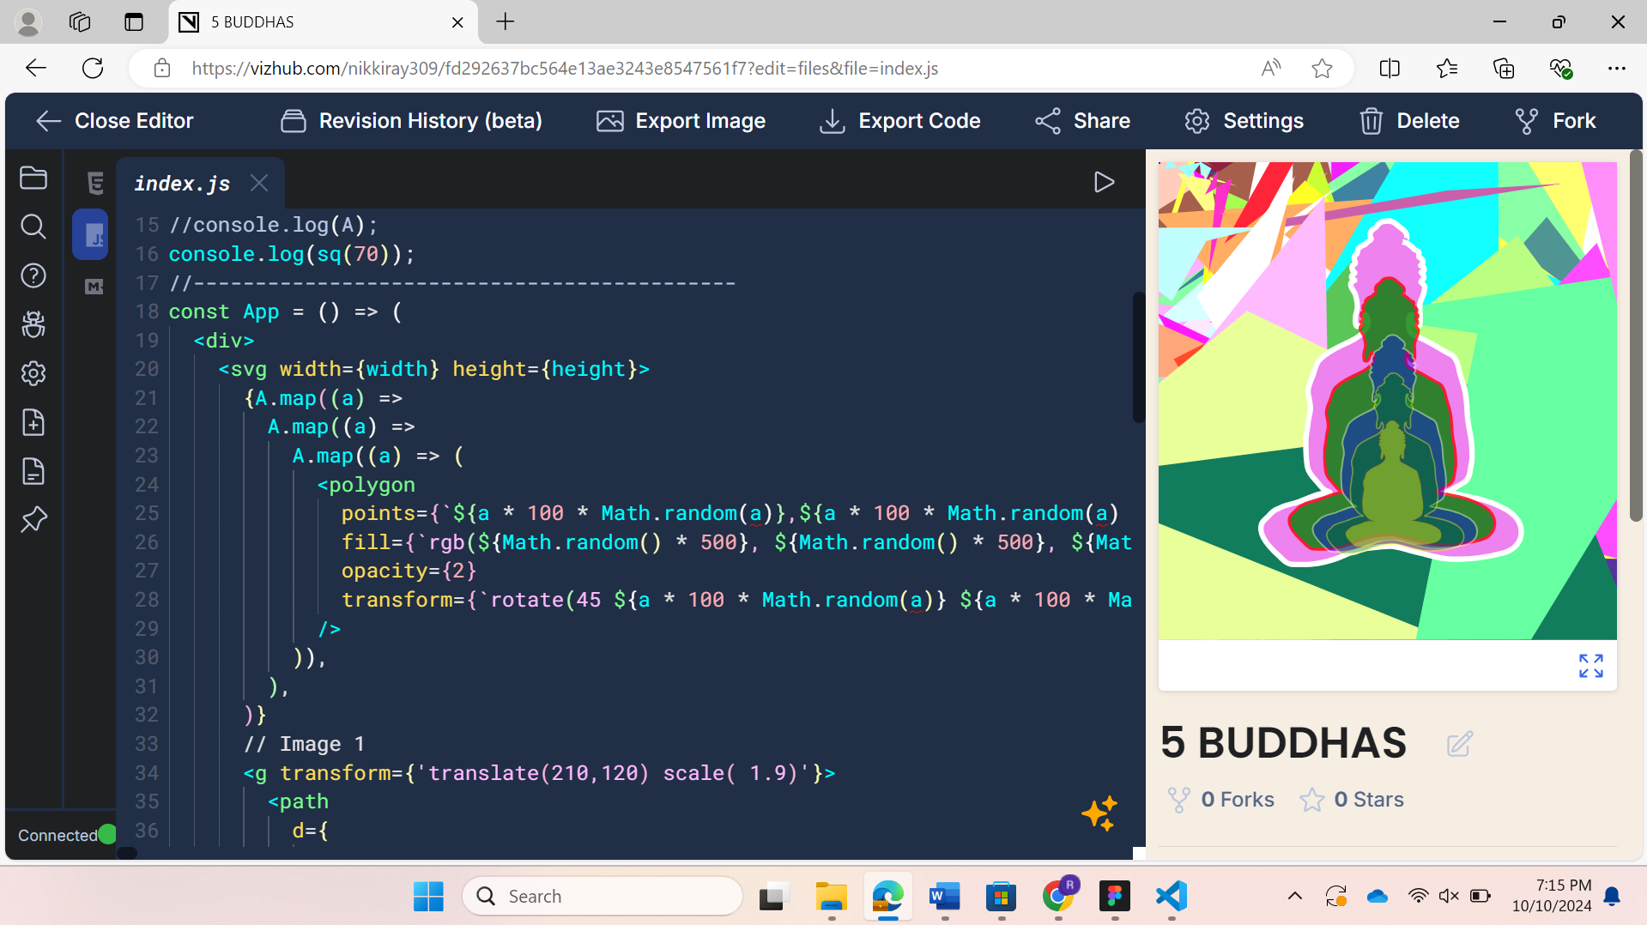

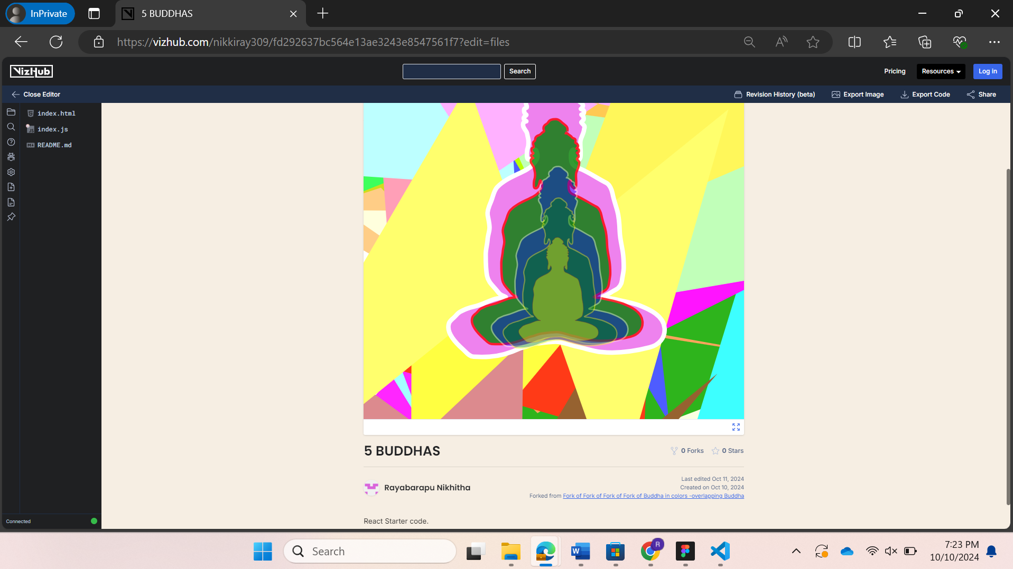

My vizhub link: [5 BUDDHAS (vizhub.com)](https://vizhub.com/nikkiray309/fd292637bc564e13ae3243e8547561f7?edit=files)

**Questions:**

1.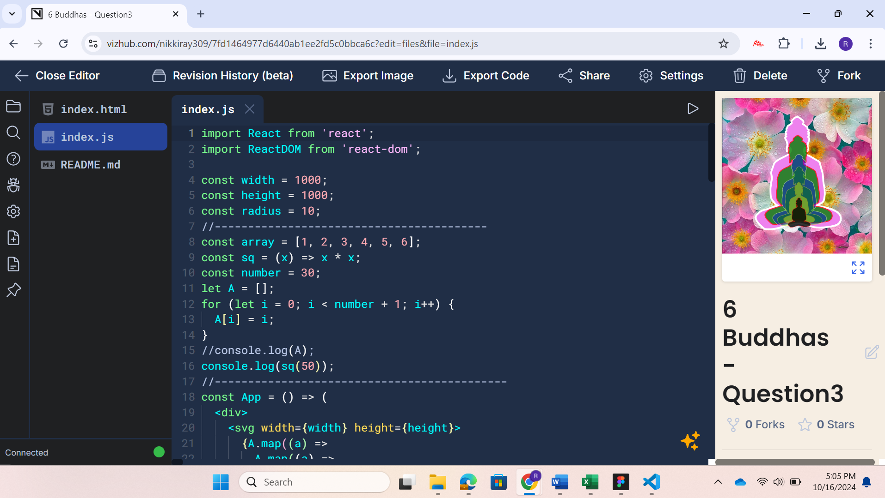

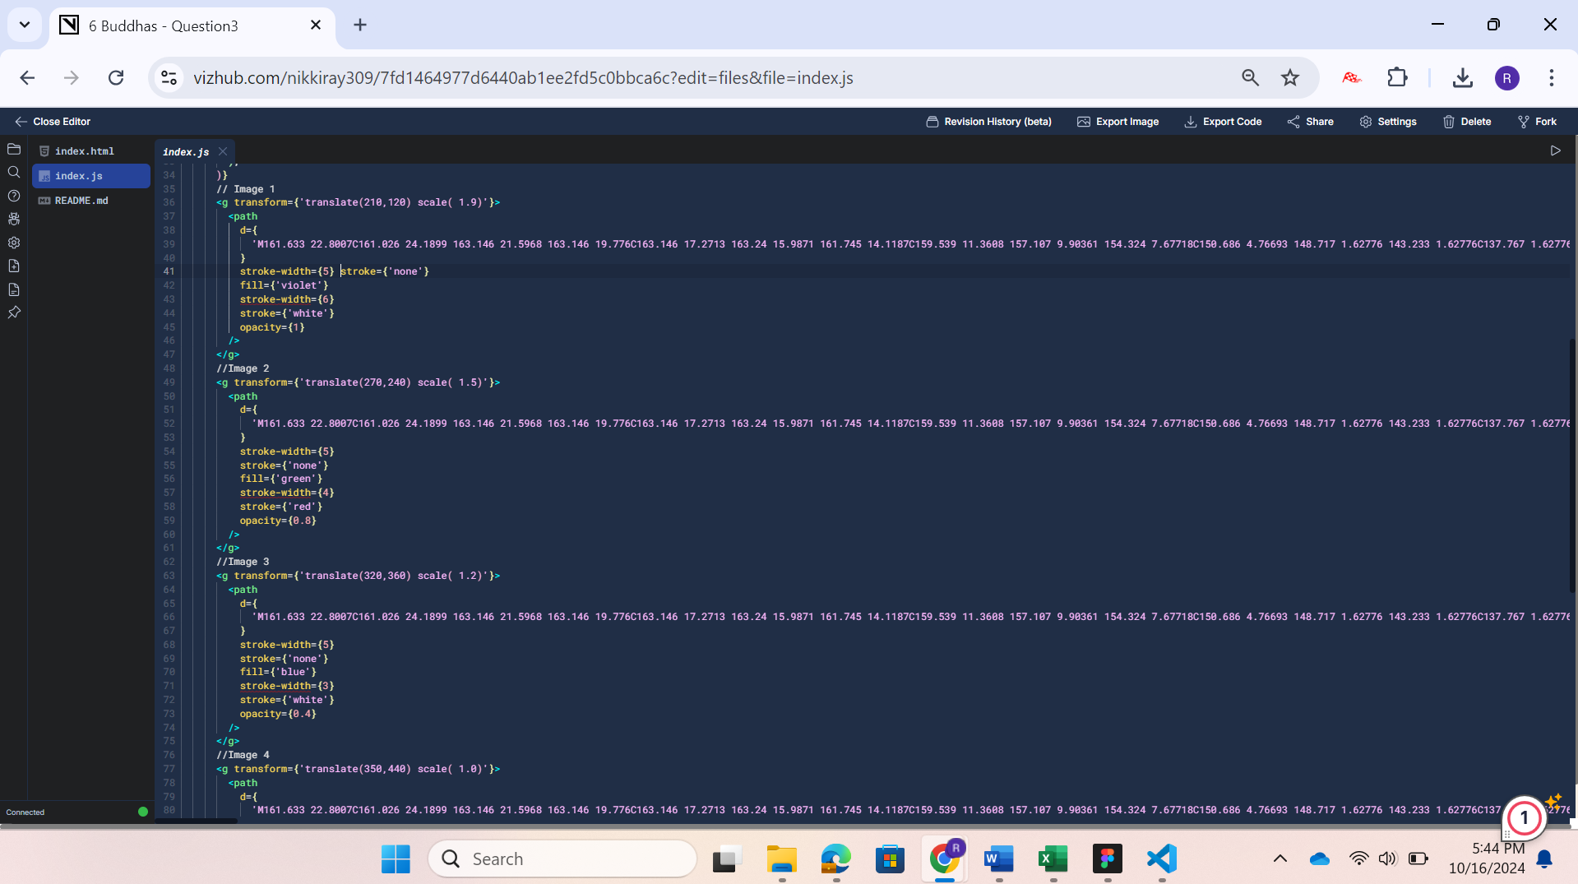

2.

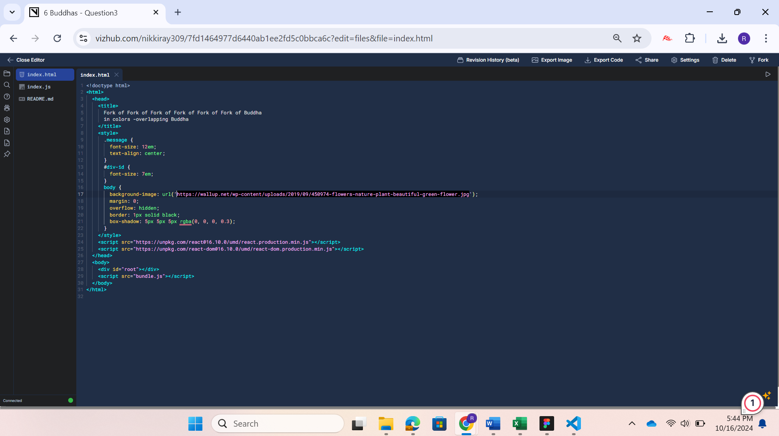

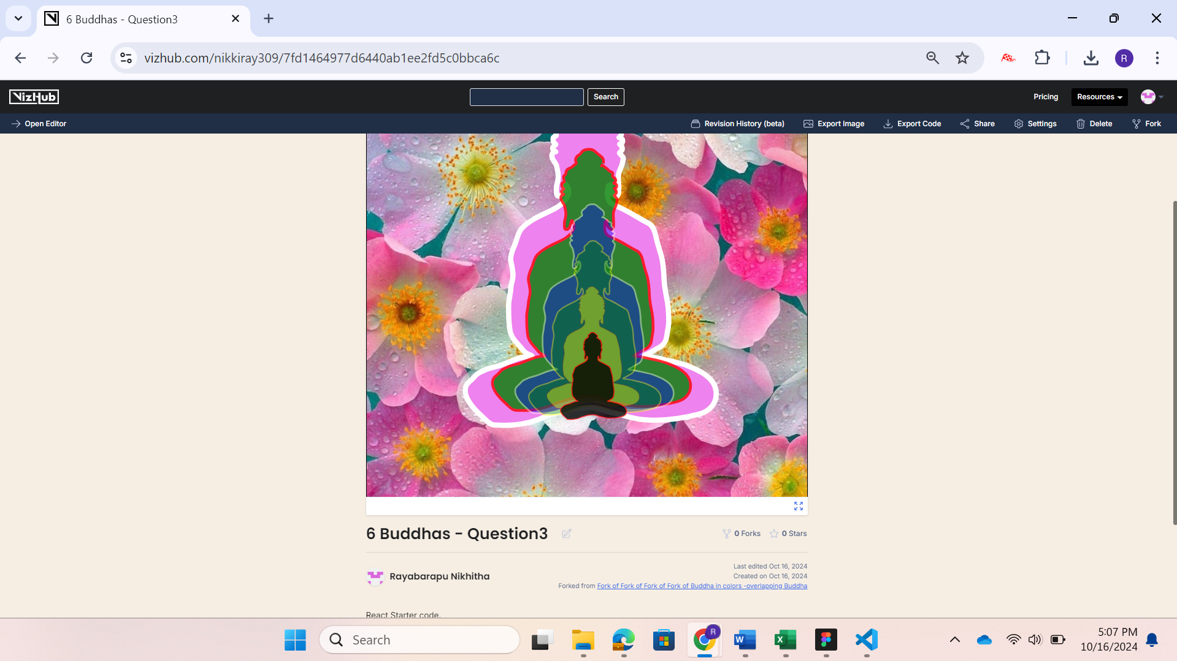

My vizHub link: <https://vizhub.com/nikkiray309/7fd1464977d6440ab1ee2fd5c0bbca6c>

**3. Explanation:**

**Step 1:** Open Vizhub and fork the visualization with two buddhas.

**Step 2:** Change the code below in **index.js**:

<g transform={'translate(210,120) scale( 1.9)'}>

<path

d={ 'M161.633 22.8007C161.026 24.1899 163…. }

stroke-width={5} stroke={'none'} fill={'violet'} stroke-width={6} stroke={'white'} opacity={1}

/>

</g>

Change the values in translate() and scale() to manipulate the size of Buddha and create 6 different images as asked.

**Step 3:** Change the background by adding the URL in the index.html code

**Step 4:** Run the code and share the link